**Anudip Foundation – AJP Lab 5**

***1. Create an abstract class Shape with abstract method calculateArea() and implement it in Circle and Rectangle.***

// Abstract class Shape

abstract class Shape {

    abstract void calculateArea();

}

// Circle class

class Circle extends Shape {

    double radius;

    Circle(double radius) {

        this.radius = radius;

    }

    void calculateArea() {

        double area = Math.PI * radius * radius;

        System.out.println("Area of Circle: " + area);

    }

}

// Rectangle class

class Rectangle extends Shape {

    double length, breadth;

    Rectangle(double length, double breadth) {

        this.length = length;

        this.breadth = breadth;

    }

    void calculateArea() {

        double area = length * breadth;

        System.out.println("Area of Rectangle: " + area);

    }

}

// Test class

class MainShape {

    public static void main(String[] args) {

        Shape c = new Circle(3);

        Shape r = new Rectangle(2,3);

        c.calculateArea();

        r.calculateArea();

    }

}

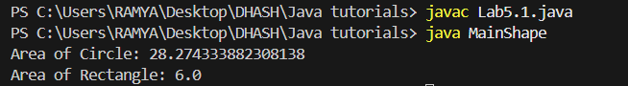

***2. Create an interface Database with method connect() and implement it in MySQLDatabase and OracleDatabase.***

// Interface Database

interface Database {

void connect();

}

// MySQLDatabase class

class MySQLDatabase implements Database {

public void connect() {

System.out.println("Connecting to MySQL Database...");

}

}

// OracleDatabase class

class OracleDatabase implements Database {

public void connect() {

System.out.println("Connecting to Oracle Database...");

}

}

// Test class

public class MainDatabase {

public static void main(String[] args) {

Database mysql = new MySQLDatabase();

Database oracle = new OracleDatabase();

mysql.connect();

oracle.connect();

}

}

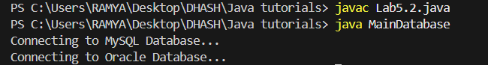

***3. Real-time: Create an interface Payment with method pay() and implement it in classes UPI, CreditCard, NetBanking***.

// Interface Payment

interface Payment {

void pay(double amount);

}

// UPI class

class UPI implements Payment {

public void pay(double amount) {

System.out.println("Paid" + amount + " using UPI.");

}

}

// CreditCard class

class CreditCard implements Payment {

public void pay(double amount) {

System.out.println("Paid" + amount + " using Credit Card.");

}

}

// NetBanking class

class NetBanking implements Payment {

public void pay(double amount) {

System.out.println("Paid" + amount + " using Net Banking.");

}

}

// Test class

public class MainPayment {

public static void main(String[] args) {

Payment p1 = new UPI();

Payment p2 = new CreditCard();

Payment p3 = new NetBanking();

p1.pay(500.0);

p2.pay(1200.0);

p3.pay(800.0);

}

}

